TITLE OF THE ARTICLE IN ENGLISH

Name SURNAME , Name SURNAME

Abstract
A concise description of the contribution in the number of maxes. 1000 characters.

Introduction of the article
Exemplary text, constant increase in traffic …

Title
Exemplary text, a geogrid is a geosynthetic element used …

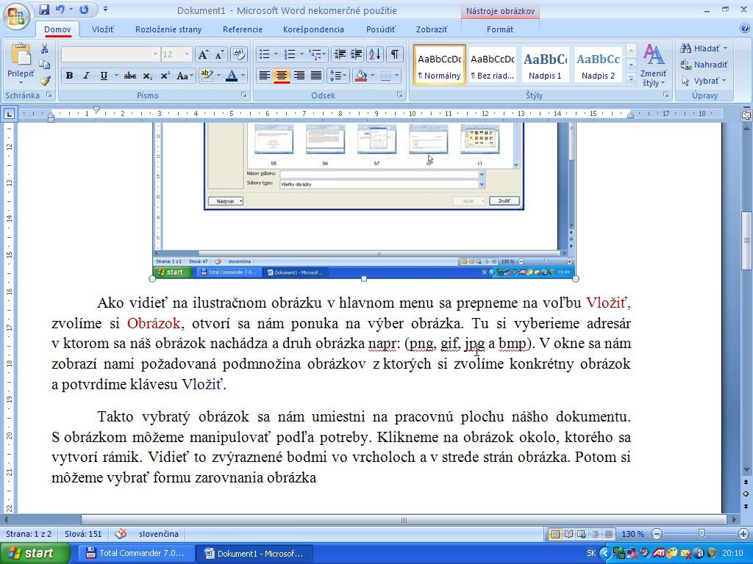
Fig. 1: Name of the picture in English language

It is clear from the picture that …

Next title
Text in the next chapter …
Tab. 1 Table of align right

Subtitle 1
Description in subsection 1 …
(1)

Subtitle 2
Computational model …

Subtitle 3
Exemplary text, Real behavior of the structure …

Conclusions from the analysis
Based on the results achieved …

Literature
- AUTHOR 1, AUTHOR 2.: Title of the article, Title of the collection/title of the book, volume, edition, publisher, ISBN. Year.

Name, Surname, Title, Address, Company...
Name, Surname, Title, Address, Company...

